**Master Functional Document**

|  |  |
| --- | --- |
| **Application** | NGERP - Centra |
| **Service Bundle** | Master Management |
| **Service Request** | NTA Receipt Allocation |

**Description :**

NTA Receipt Allocation screen is used to allocate the NTA AR invoice and NTA Receipt.

**Workflow Process :**

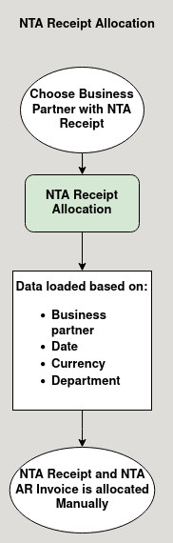

**Business Rules :**

* NTA Receipt Allocation screen can be only accessed in HQ.
* This screen is used to allocate NTA AR invoice and NTA Receipt.
* NTA AR invoice document with completed status is shown in invoice tab.
* The data loaded in this tabs are based on:
  + Business Partner
  + Date
  + Currency
  + Department
* These are chosen by the user.
* NTA Receipt document with completed status in Payment tab.
* User should choose the business partner to whom they want to allocate the payment.
* User can only able to manually allocate the NTA AR Invoice with the NTA Receipt.
* User can allocate partial or full payment to the NTA AR invoice.
* The allocated payment can be viewed in the view allocation tab.